Creating & Searching for Sites

[Echoes - Land Management](https://echoes-platform.eu/app/main/map-view)

14 Steps

Go to <https://echoes-platform.eu/app/main/sites/my-sites>

1 - Creating a New Site

Click on the 'Create New Site' button

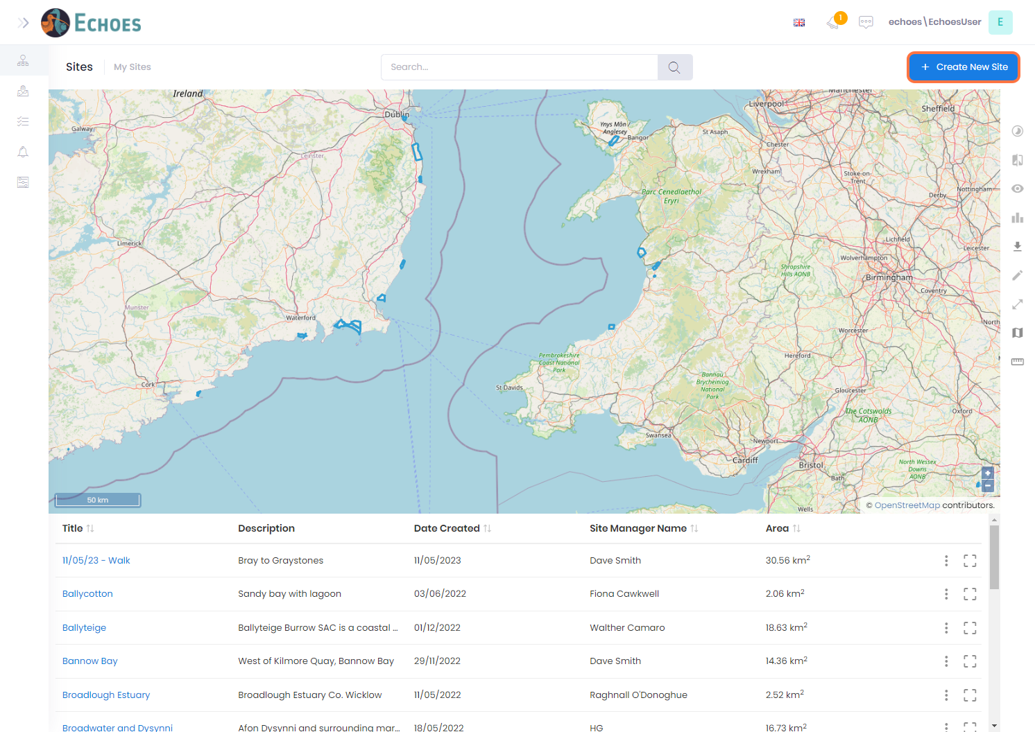

2 - Zoom to the area you want to create a Site

Zoom into the area you wish the create the site, using the scroll wheel or Click on the + icon, then click and drag your mouse to pan around the map.

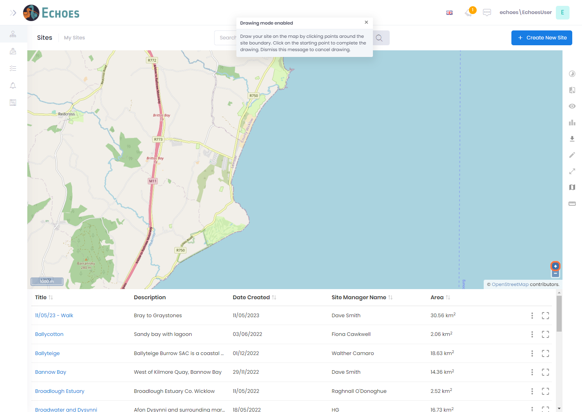

3 - Drawing the outline of your Site

Once you have zoomed into your area, click on the map to start your 1st point in drawing the sites boundary. Continue clicking around the site until you reach the start. Don't worry about the polygon being perfect, this can be edited at any time.

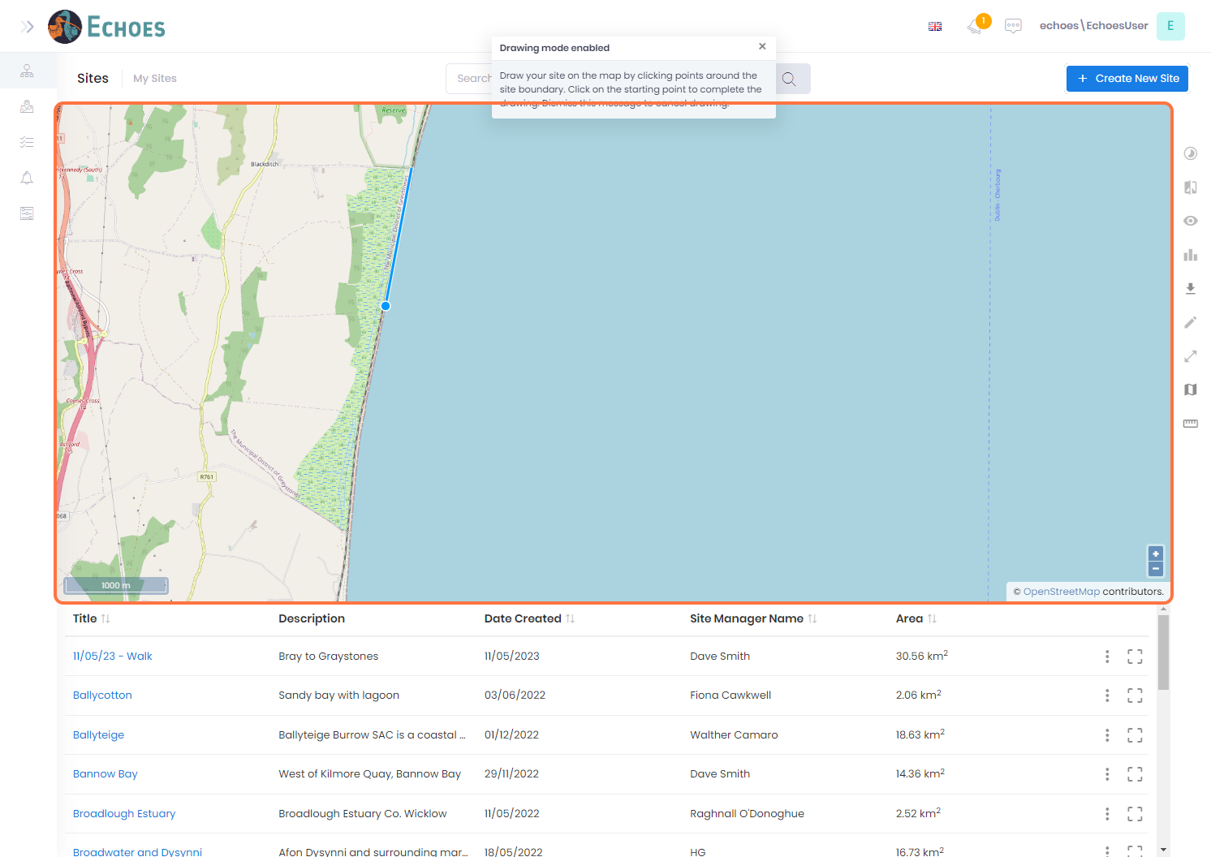

4 - Create sites details

Once the boundary is complete, you will now see this information popup form appear, this must be completed to save your site.

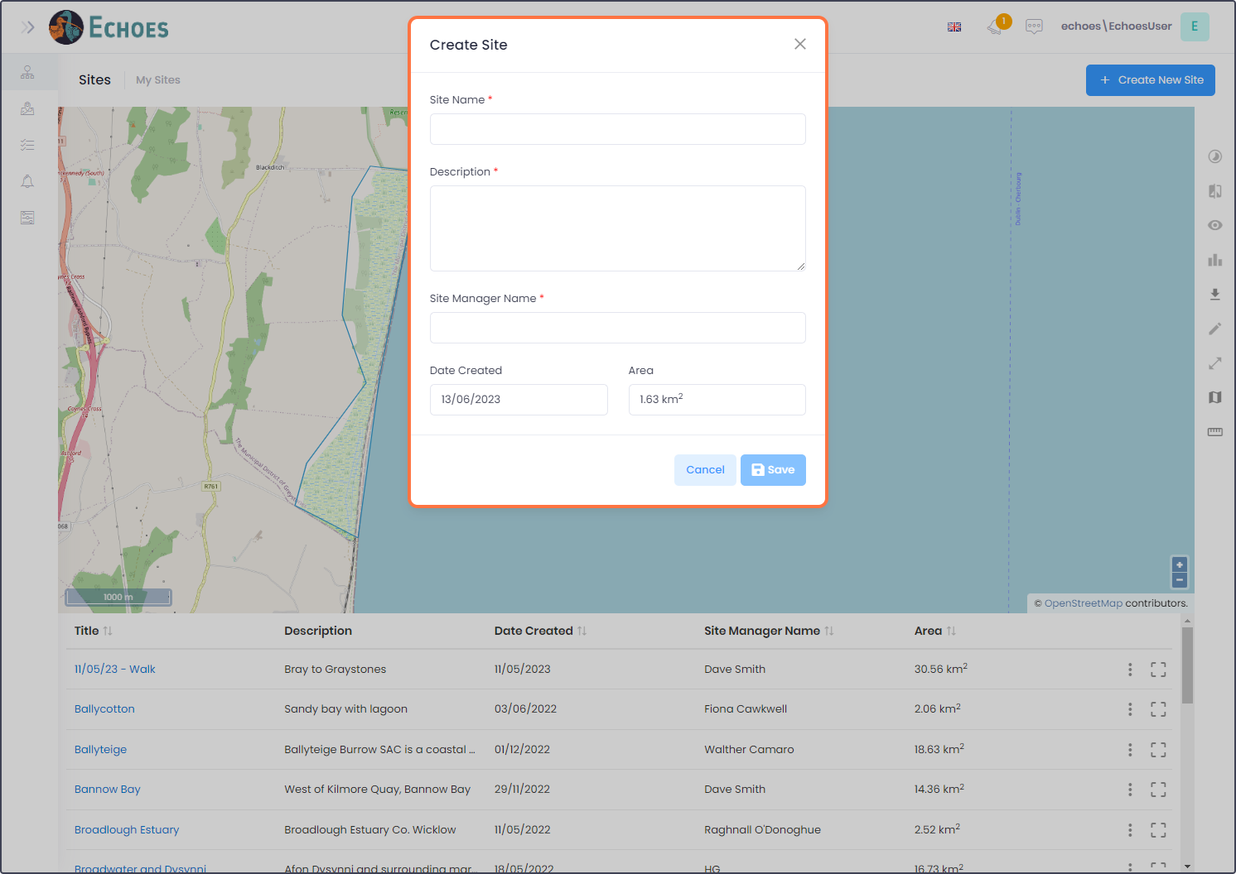

5 - Site information (1/3)

Enter a name for your site.

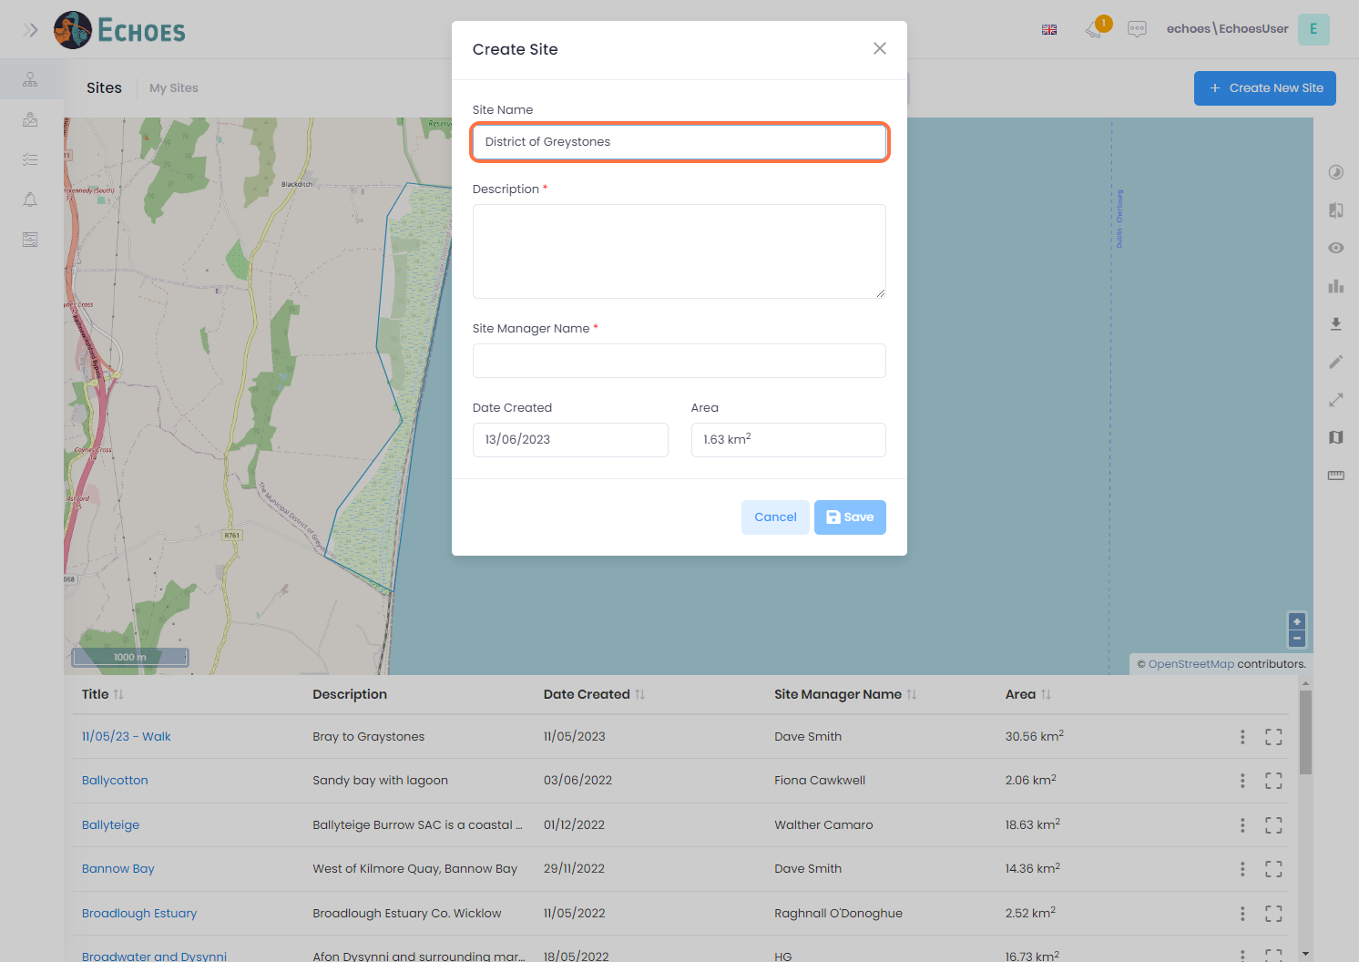

6 - Site information (2/3)

Enter a description for your site.

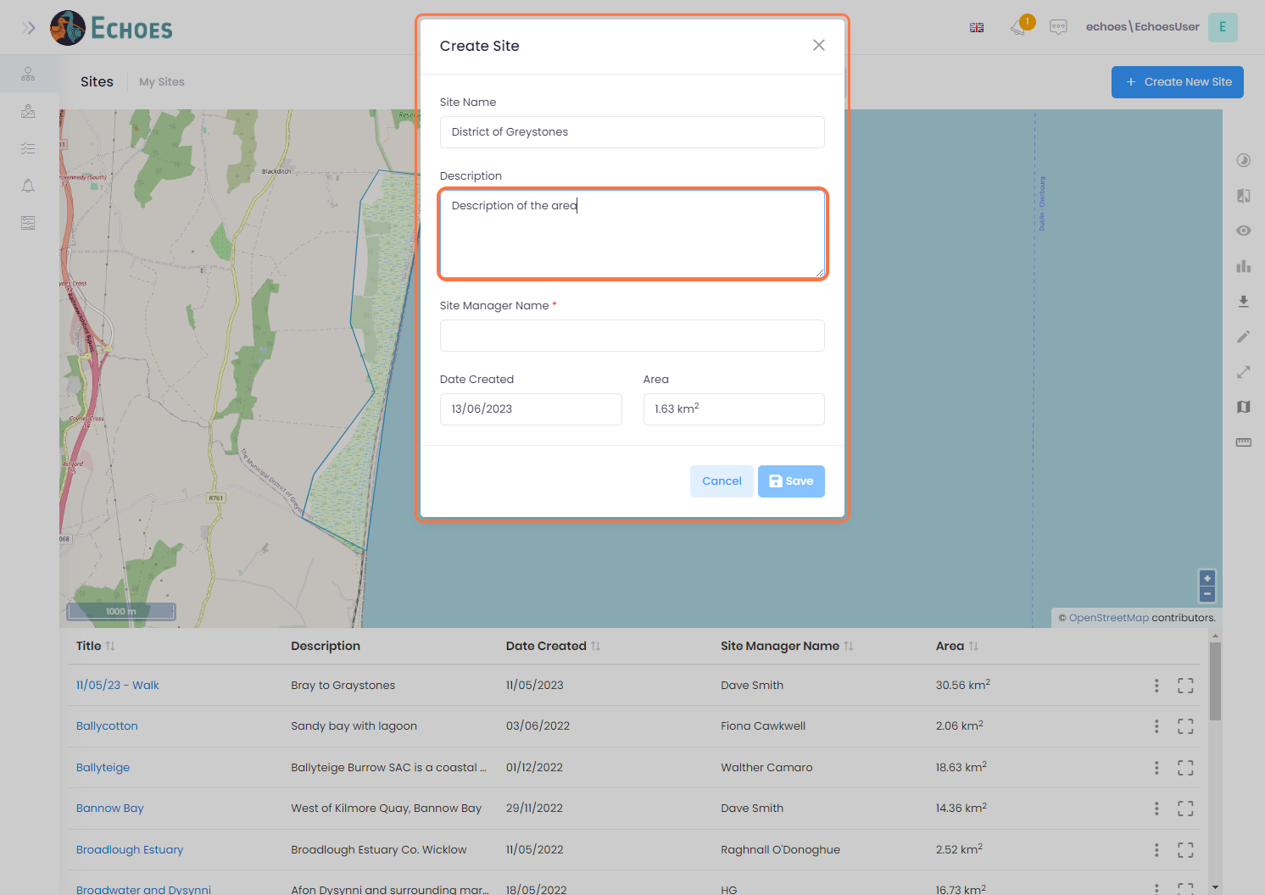

7 - Site information (3/3)

Enter the site managers name for your site.

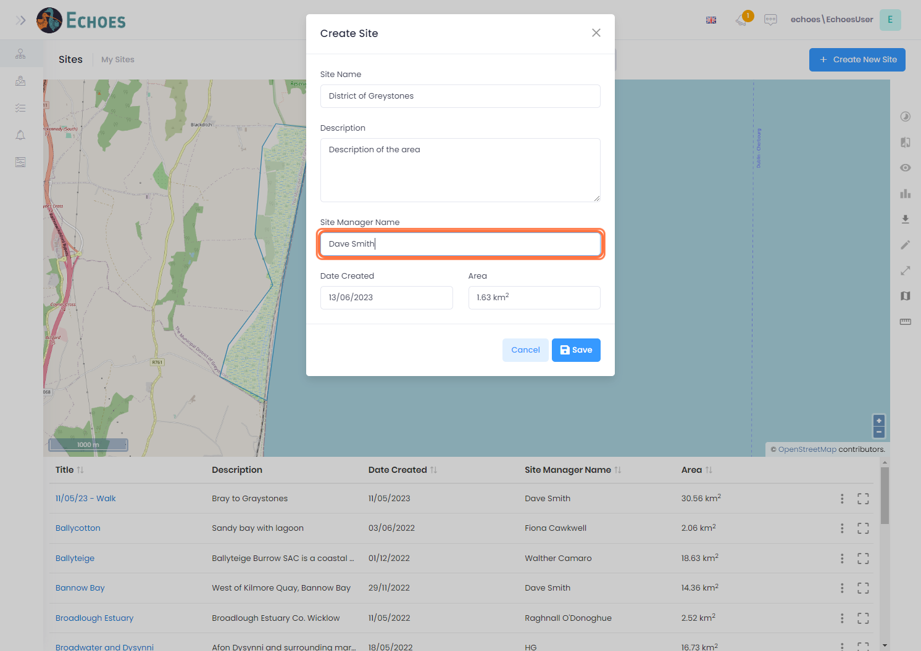

8 - Saving your site

Click on the Save button

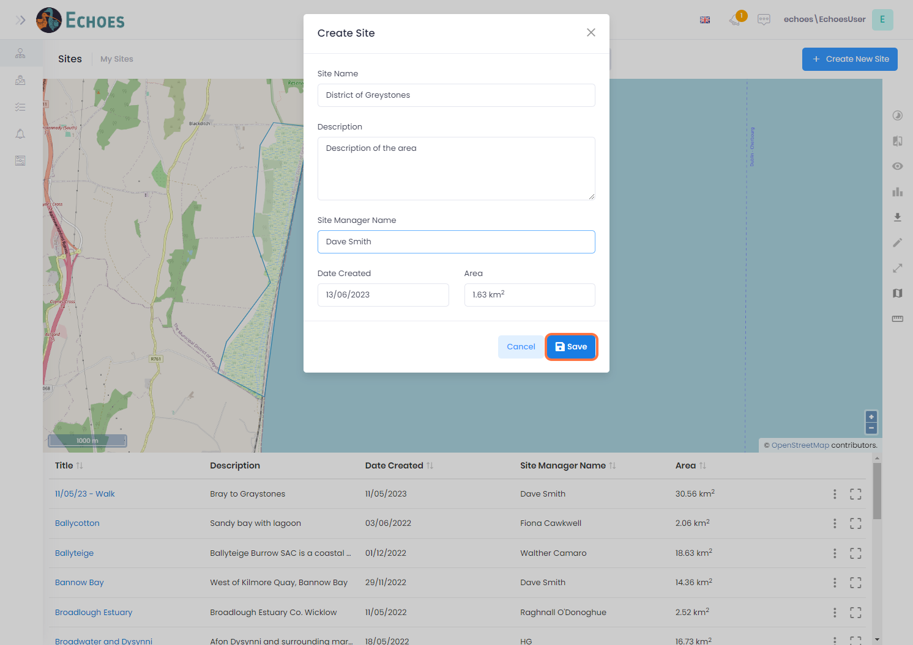

9 - Searching for your Site

You can search for a site by using the search bar to search for any word in the Tile or the Description.

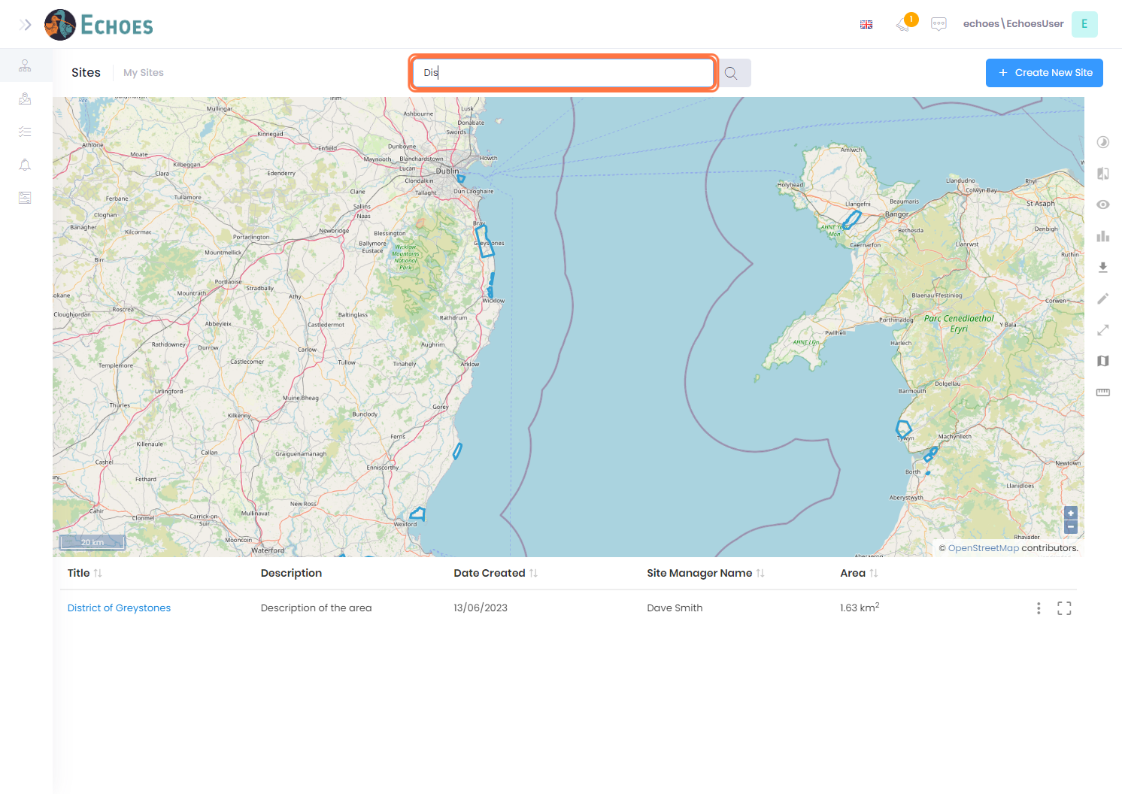

10 - Results in the data grid

Any results will show in the data grid below.

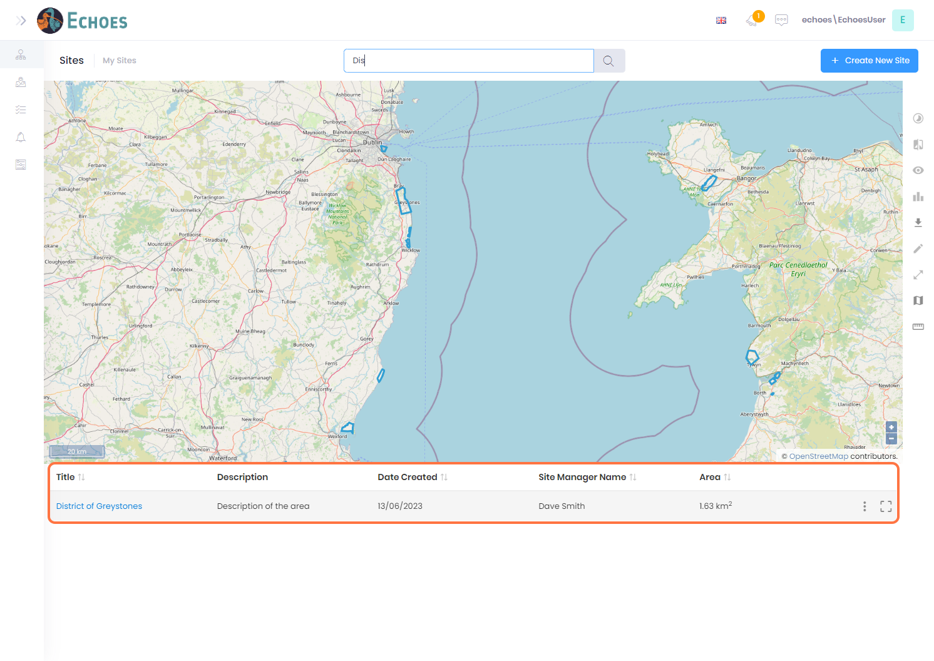

11 - Zooming to your site

You can click on the 'Zoom to' icon to zoom to the extent of that site on the map.

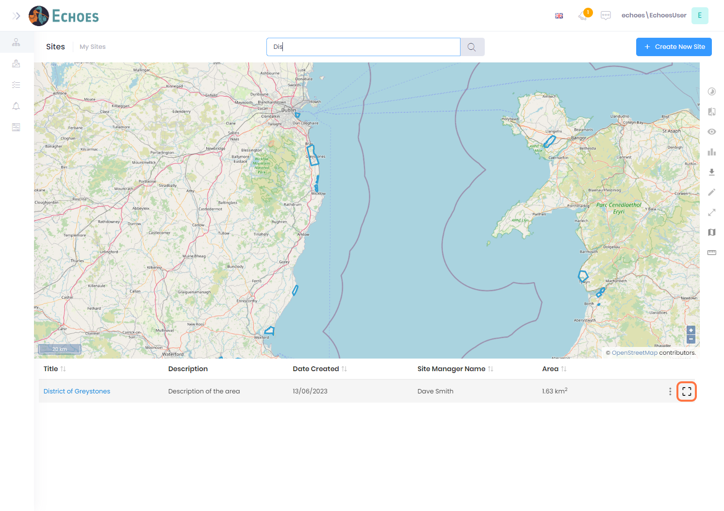

12 - Zoom to example

Example after using the 'Zoom to' icon

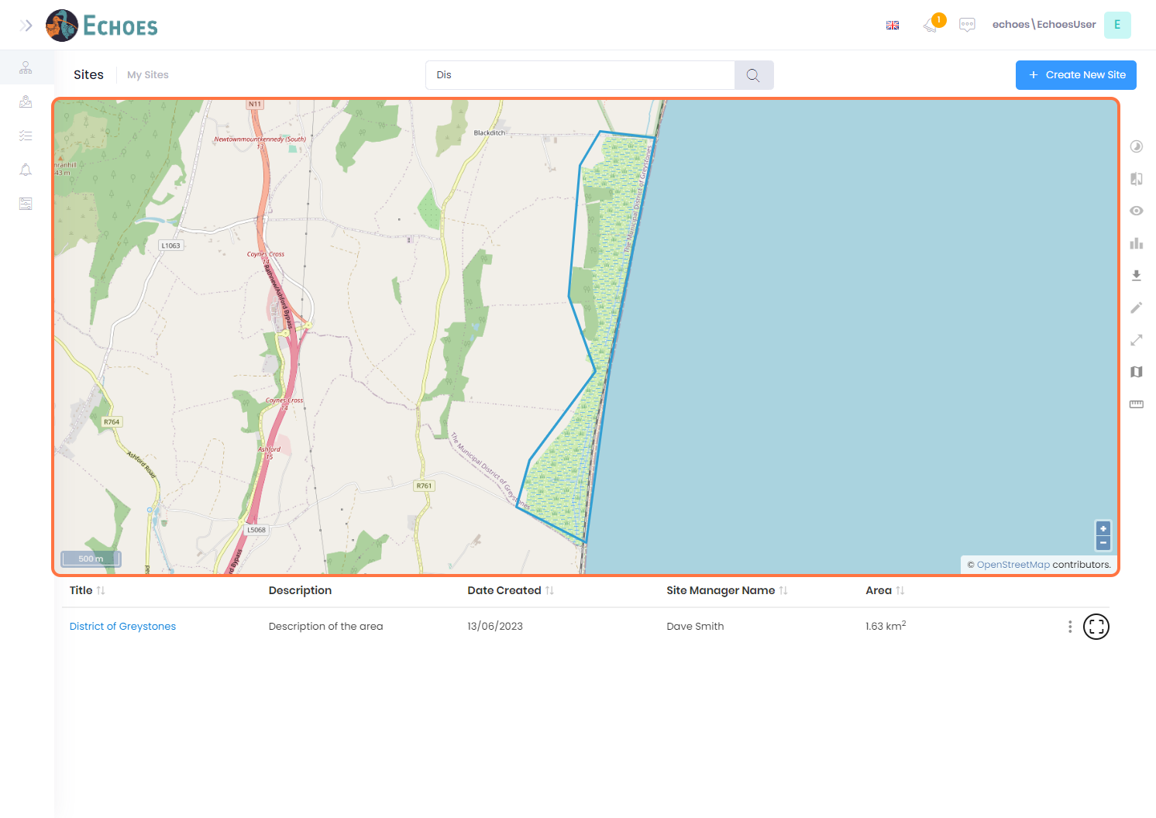

13 - Taking actions on your site (1/2)

Clicking the ellipses icon, you can then choose any of the options from the list to perform that action.

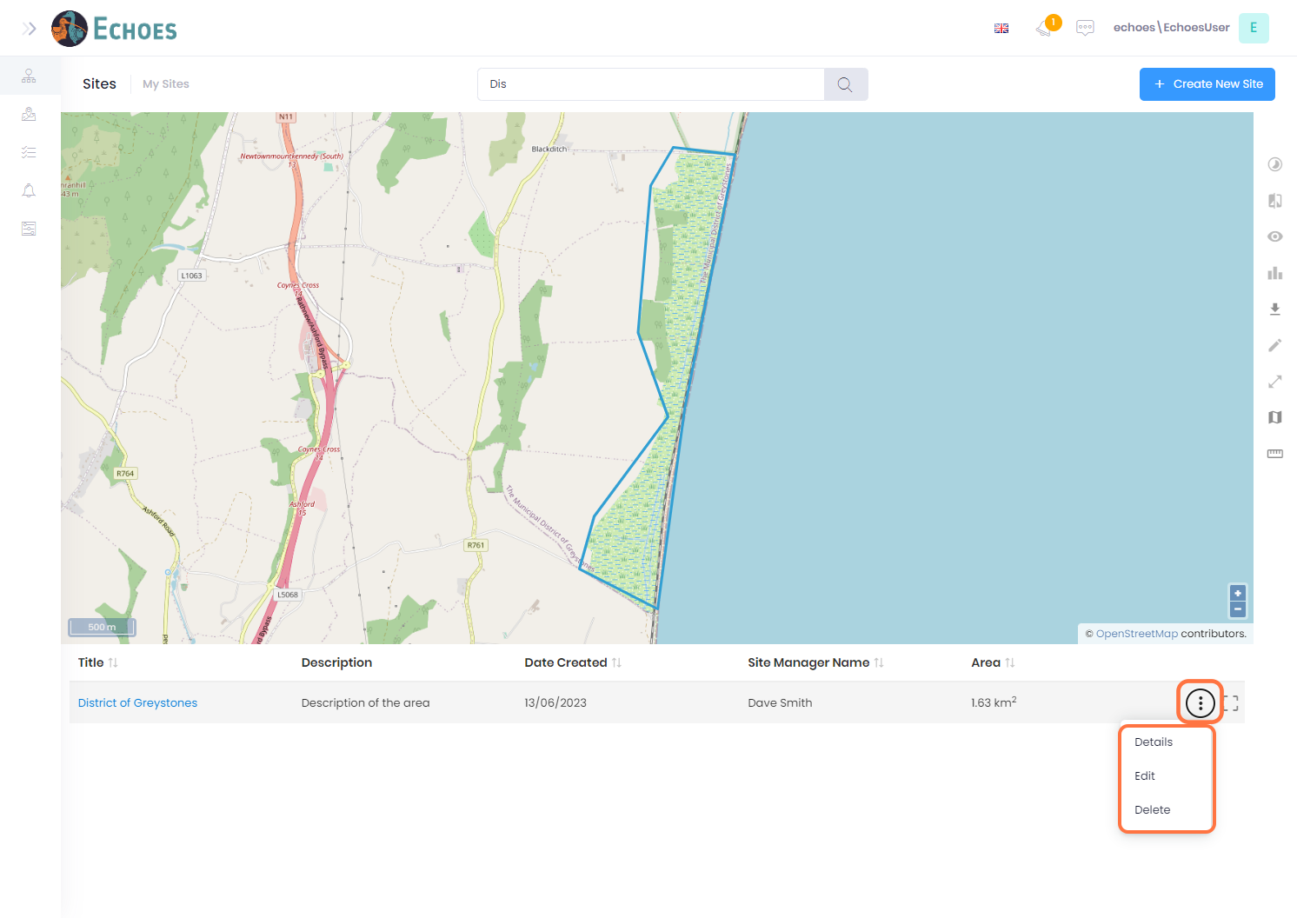

14 - Taking actions on your site (2/2)

Clicking within your sites boundary will present you with this popup. Here you can click the 'See Site Details' button to see all details and associations of this site (more information can be found from steps 4-11 of the **View & Edit Sites Details** doc)

You can also click the 'Actions' button this will give you a list of actions you can take on that site.

